2. For a given set of training data examples stored in a .CSV file, implement and demonstrate the
Candidate-Elimination algorithm in python to output a description of the set of all hypotheses
consistent with the training examples
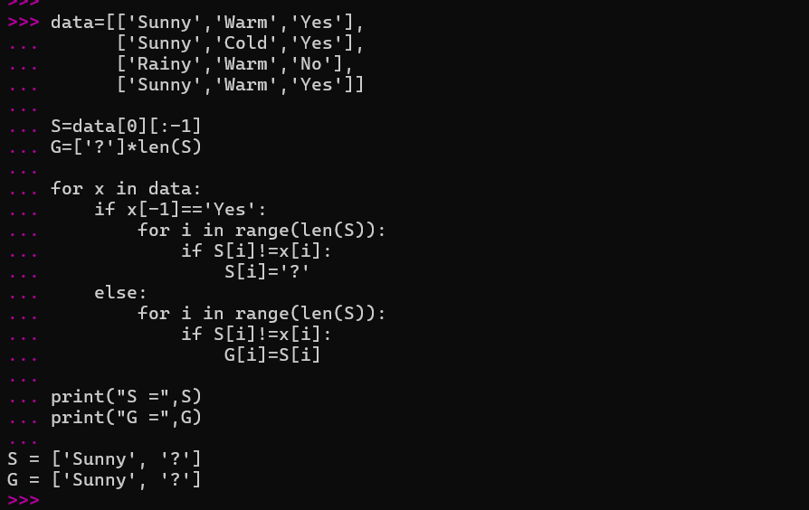
3. Demonstrate the working of the decision tree base

